Project Design Phase-II
Data Flow Diagram & User Stories

Date | 15-07-2026
Team ID
Project Name | ShopEZ – Full Stack MERN E-Commerce Platform
Maximum Marks | 4 Marks

Data Flow Diagrams:
A Data Flow Diagram (DFD) is a traditional visual representation of the information flows within a system. A neat and clear DFD can depict the right amount of the system requirement graphically. It shows how data enters and leaves the system, what changes the information, and where data is stored.

Example: (Simplified)


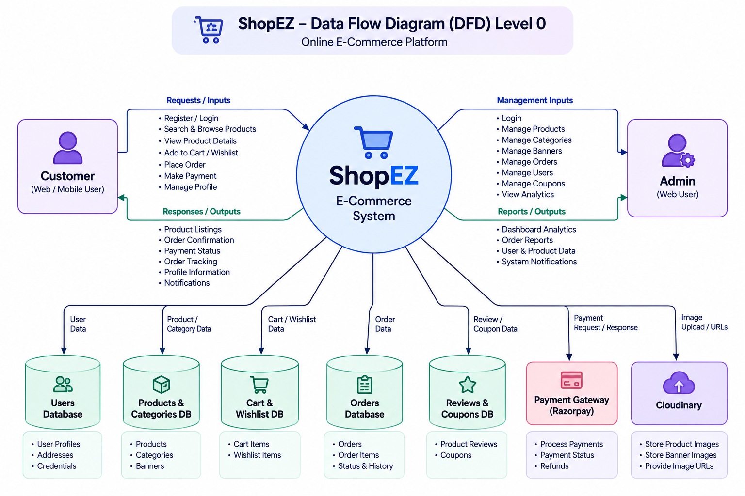
User Stories

User Type | Functional Requirement (Epic) | User Story Number | User Story / Task | Acceptance criteria | Priority | Release
Customer | Registration | USN-1 | As a user, I can register for the application by entering my email, password, and confirming my password. | I can access my account / dashboard | High | Sprint-1
 |  | USN-2 | As a user, I will receive confirmation email once I have registered for the application | I can receive confirmation email & click confirm | High | Sprint-1
 |  | USN-3 | As a user, I can register for the application through Facebook | I can register & access the dashboard with Facebook Login | Low | Sprint-2
 |  | USN-4 | As a user, I can register for the application through Gmail | As a customer, I can register using my email and password. | Medium | Sprint-1
 | Login | USN-5 | As a user, I can log into the application by entering email & password | As a customer, I can log in securely. | High | Sprint-1
 | Products | USN-6 | As a customer, I can browse products. | Products are displayed. | HIgh | Sprint-1
 | Wishlist | USN-7 | As a customer, I can save products to my wishlist. | Wishlist updates successfully. | Medium | Sprint-2
 | Orders | USN-8 | As a customer, I can track my orders. | Order status is displayed. | High | Sprint-3
Administrator | Login | USN-9 | As an admin, I can log in securely. | Admin dashboard opens. | High | Sprint-3
 | Products | USN-10 | As an admin, I can add products. | Product is added. | High | Sprint-1
 | Categories | USN-11 | As an admin, I can manage categories. | Categories update successfully. | High | Sprint-2
 | Orders | USN-12 | As an admin, I can manage orders. | Order status updates. | High | Sprint-3

